

DISSOLVED OXYGEN SENSOR

DOV



CONFIDENTIAL. PROPERTY OF MEDEVPLUSTM.

This information belongs to and copyrighted by Tishyas Medical Device Development Solutions Pvt Ltd. (2018-20). Use of this information without permission is subject to legal action. The Author abides by this law.

**Table of Content**

***Part 1 - Introduction***

About Fiber Optic Do Sensor

***Part 2 - Simulation***

Optical simulation through Zemax Software

***Part 3 - Responsivity Studies of DO Sensor***

Experiment 1

Experiment 2a

Experiment 2b

***Part 4 - Sensitivity Studies***

30 Minutes Readings

1pF 30 Minutes Readings

10pF 15 Minutes Readings

101pF 15 Minutes Readings

**Part -1**

**Introduction**

* **About Fiber Optical DO Sensor:**

Optics is most recent technology in Dissolved Oxygen Sensor. The DO measurements is obtained without using a membrane, electrolyte or electrodes, but this sensor is mainly based on the Laser Light source of luminosity and the photo detector which makes it faster than the electrochemical sensors.

* **Dissolved Oxygen Sensor Technology:**

S2386 Detector’s

LM2596 Buck IC

RS485 USB to RS485

STM32F103

Micro controller

ADC1115 Analog to Digital converter

D1 D2 D3

Analog Output

Digital Output

Pigtailed Laser’s

**Part-2**

**Simulations of DO Sensor**

The optical simulations of the DO Sensor are done by the Zemax software, we can analyse the input power and output power of lasers in the present of pure water, dissolved oxygen from the resulting figure and the values shown below.

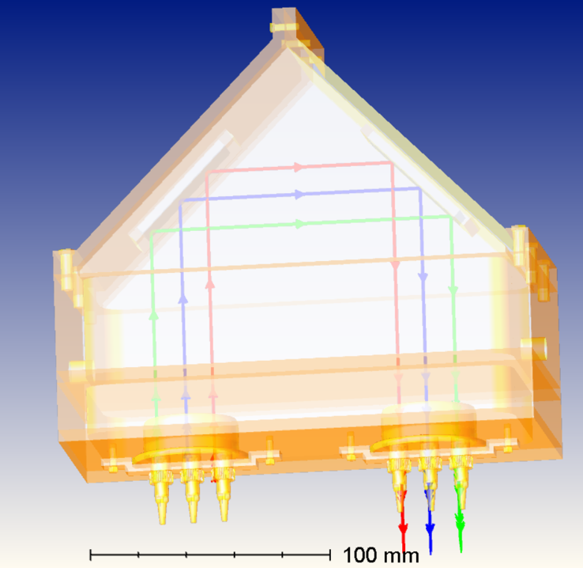

The above image illustrates the path traverse by laser light to reach detector using Zemax Optics studio

* **Observation done in Zemax:**
  + **Power Input for Red Laser 650nm:** 5 m Watt
  + **O/P Power for** **Dissolved oxygen in Zemax simulation:**  3.48 *10^-4 Watt or 0.4 m Watt
  + **O/P Power for Pure Water in Zemax simulation:**  2.53 *10^-3 Watt or 2.53 m Watt
* **Waveforms Plotted in Zemax:**

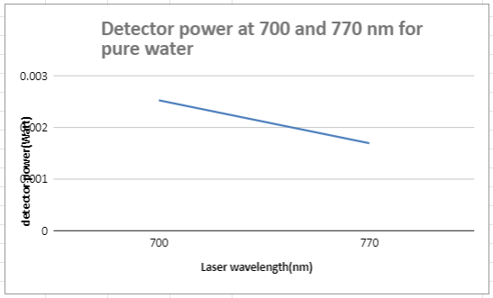

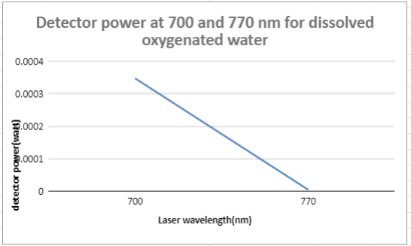

**Part-3**

**Responsivity Studies of DO Sensor**

Many experiments are been performed on the Do Sensor for circuit analysis and using Python and Arduino codes for data acquisition.

* **Experiment 1:**

The DO Sensor have two circuits in the first experiment that are

* + **Laser Driver & Detector Circuits:**

The circuit figures and the values of those both circuits are shown below.

* + **Components Requried:**
    - LM317 voltage regulator
    - 12v Dc Adapter
    - Op-amp IL358N & LM741
    - POT, 1kohms Variable Resistor
    - 3 pigtailed Laser’s
    - Resistor’s 100 & 1k ohms
    - Photo diode
    - Capacitor 3pF

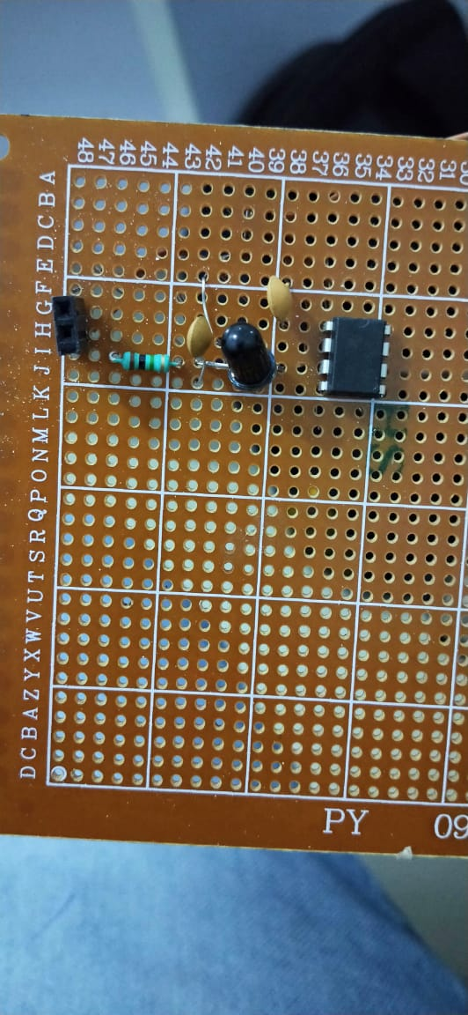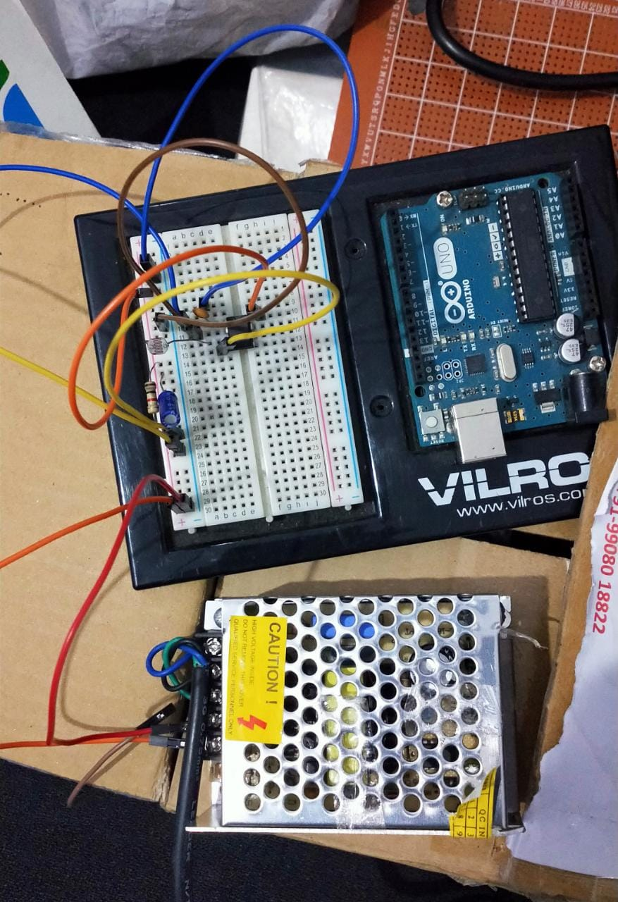

*Detector Circuit with LDR & Photodiode*

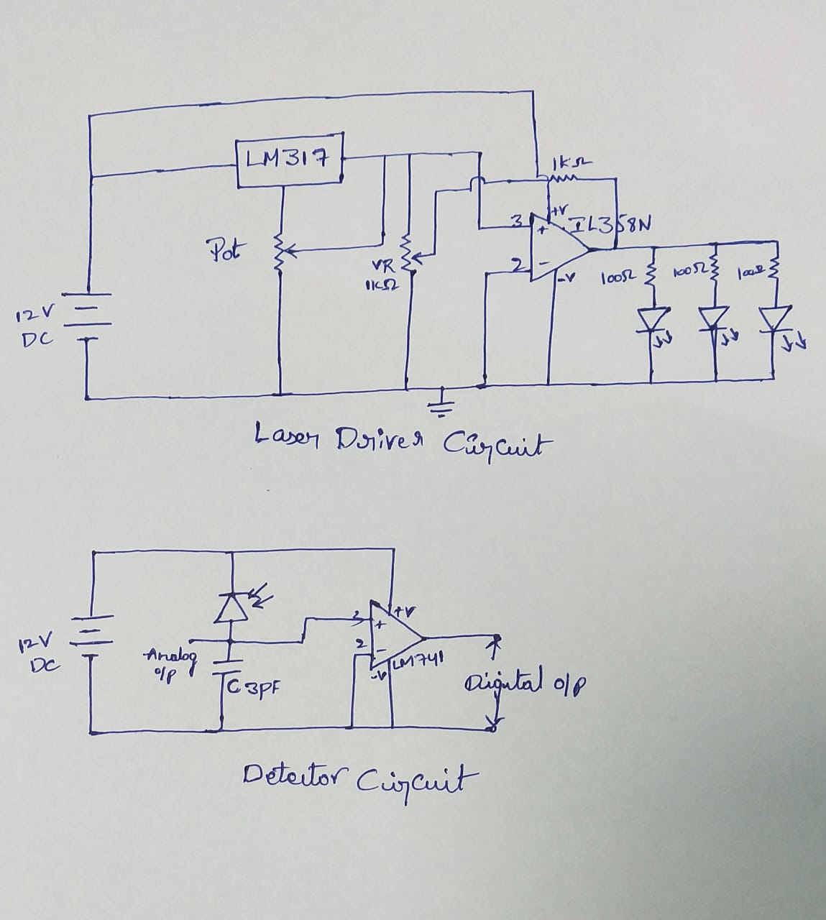

**Calculations:**

The laser driver circuit measurements are taken through detector circuit with the photodiode

|  |  |
| --- | --- |
| **Values in Volts** | **Values in Amp** |
| 0.212V | 6mA |
| 1V | 10mA |
| 1.5V | 14mA |
| 2V | 20mA |
| 2.5V | 24mA |
| 3V | 30mA |
| 3.5V | 34mA |
| 4V | 40mA |
| 4.5V | 45mA |
| 5V | 49mA |
| 6.72V | 70mA |

|  |  |  |  |  |  |
| --- | --- | --- | --- | --- | --- |
| **Input Volts** | **Without laser at detector** | **With laser at detector** | **Without laser at detector** | **With laser at detector** | **Power**  **V*A** |
| 3.5V | 4.216V | 4.402V | 37mA | 39mA | 171mW |
| 4v | 4.216V | 4.651V | 37mA | 43mA | 191mW |
| 4.5V | 4.216V | 4.910V | 37mA | 49mA | 240mW |
| 5V | 4.216V | 5.098v | 37mA | 53mA | 270mW |

* **Graphs:**

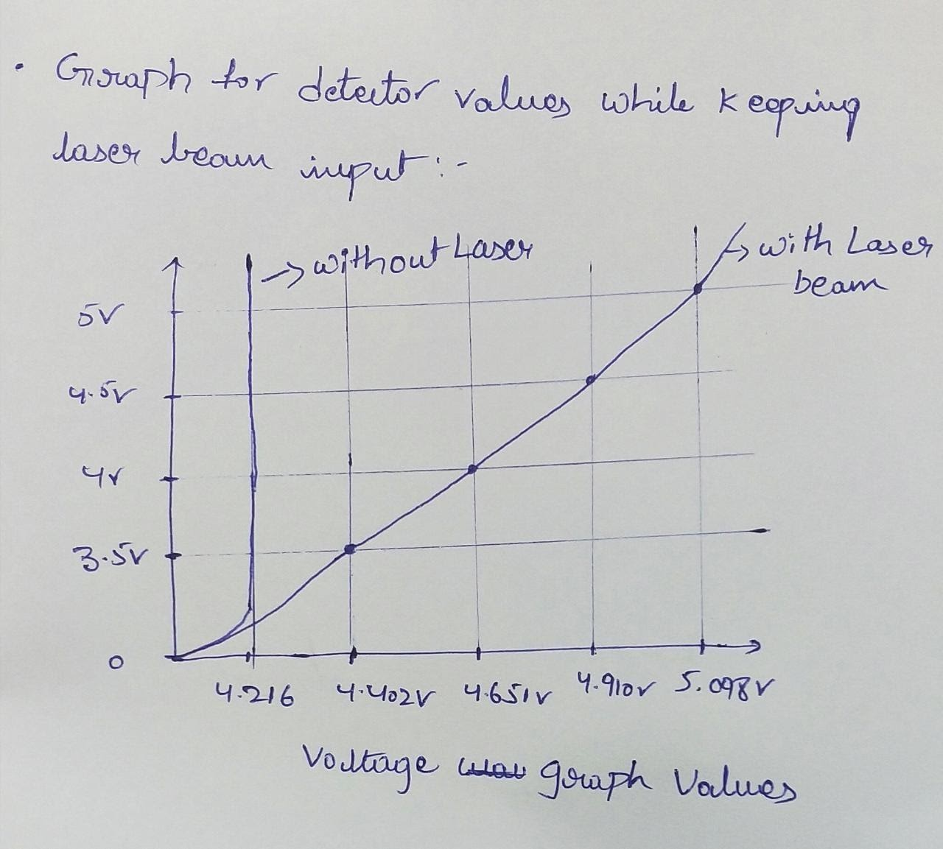

*Voltage graph*

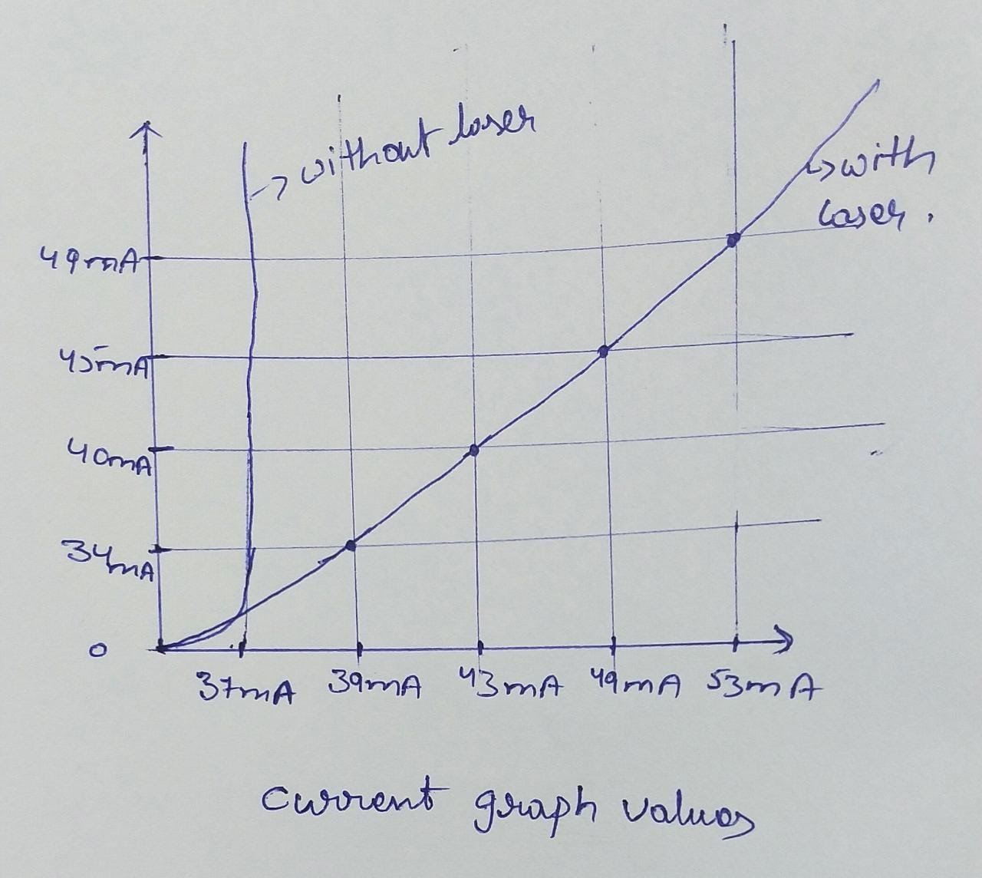

*Current graph*

* **Experiment 2(a):**

Another experiment on DO Sensor using Egismos Lasers and Hamamastu Detector

* + **Components required:**
    - Arduino UNO
    - ADS1115
    - 16*2 LCD Display
    - Buck IC LM2596
    - 3 Egismos Laser’s
    - 3 Detectors s2387
    - Mirror’s
    - Outer Module
* **DO Sensor Circuit:**

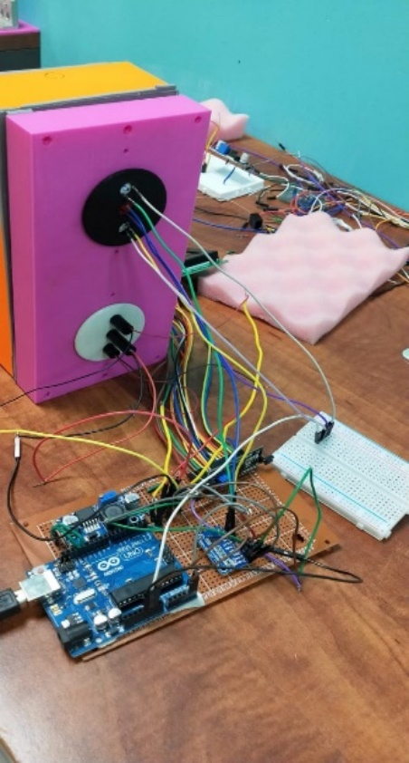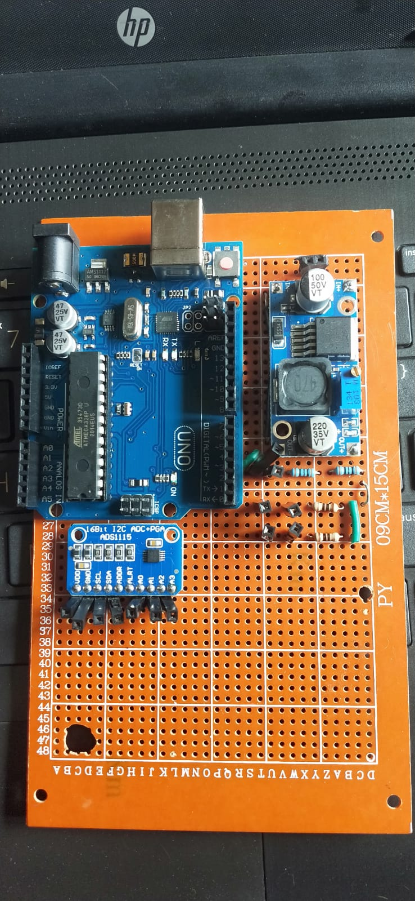

* + **Code:**

*#include <Wire.h>*

*#include <Adafruit_ADS1015.h>*

*#include <LiquidCrystal_I2C.h>*

*#define LED_BUILTIN 13*

*Adafruit_ADS1115 ads(0x48);*

*LiquidCrystal_I2C lcd(0x27, 20, 4);*

*// the setup function runs once when you press reset or power the board*

*void setup() {*

*Serial.begin(9600);*

*Serial.println("Do meter");*

*Serial.println("Getting single-ended readings from AIN0..3");*

*Serial.println("ADC Range: +/- 6.144V (1 bit = 3mV/ADS1015, 0.1875mV/ADS1115)");*

*ads.begin();*

*lcd.init();*

*lcd.backlight();*

*lcd.setCursor(0,0);*

*lcd.print(" MEDEVPLUS DO-Meter ");*

*// initialize digital pin LED_BUILTIN as an output.*

*pinMode(LED_BUILTIN, OUTPUT);*

*LCDCode();*

*delay(1000);*

*digitalWrite(LED_BUILTIN,HIGH); // turn the LED on (HIGH is the voltage level)*

*for(int i=0;i<4;i++){*

*LCDCode();*

*delay(60000);*

*}*

*}*

*// the loop function runs over and over again forever*

*void loop() {*

*digitalWrite(LED_BUILTIN, LOW); // turn the LED on (HIGH is the voltage level)*

*for(int i=0;i<7;i++){*

*LCDCode();*

*delay(60000);*

*}// wait for a second*

*LCDCode();*

*digitalWrite(LED_BUILTIN, HIGH); // turn the LED off by making the voltage LOW*

*delay(60000);*

*}// wait for a second*

*void LCDCode(){*

*int16_t adc0, adc1, adc2;*

*adc0 = ads.readADC_SingleEnded(0);*

*adc1 = ads.readADC_SingleEnded(1);*

*adc2 = ads.readADC_SingleEnded(2);*

*Serial.print("AIN0: ");*

*Serial.println(adc0);*

*lcd.setCursor(0,1);*

*lcd.print("AIN0: ");*

*lcd.print(adc0);*

*Serial.print("AIN1: ");*

*Serial.println(adc1);*

*lcd.setCursor(0,2);*

*lcd.print("AIN1: ");*

*lcd.print(adc1);*

*Serial.print("AIN2: ");*

*Serial.println(adc2);*

*lcd.setCursor(0,3);*

*lcd.print("AIN2: ");*

*lcd.print(adc2);*

*}*

* **Calculations:**
  + - For Egismos Blue laser (450nm):

|  |
| --- |
| **Exp1** |
| 31.43mW |
| 31.68mW |
| 30.16mW |
| 30.98mW |
| 30.68mW |

|  |
| --- |
| **Exp2** |
| 26.01mW |
| 25.85mW |
| 25.85mW |
| 25.75mW |
| 25.69mW |

* For Egismos Red laser (630nm):

|  |
| --- |
| **Exp1** |
| 13.65mW |
| 13.80mW |
| 14.01mW |
| 13.96mW |
| 13.72mW |

|  |
| --- |
| **Exp2** |
| 14.88mW |
| 14.58mW |
| 14.54mW |
| 14.46mW |
| 14.36mW |

* + - For Egismos Green laser (530nm):

|  |
| --- |
| **Exp1** |
| 11.82mW |
| 11.77mW |
| 11.52mW |
| 11.75mW |
| 11.82mW |

|  |
| --- |
| **Exp2** |
| 10.65mW |
| 10.57mW |
| 10.45mW |
| 10.68mW |
| 10.36mW |

* + **Look up table for detector selection for Egismos laser:**

|  |  |  |  |
| --- | --- | --- | --- |
| **Detector** | **Blue** | **Red** | **Green** |
| D1 | 0.3274 | 0.3858 | 0.2429 |
| D2 | 0.3266 | 0.3840 | 0.2441 |
| D3 | 0.3271 | 0.3844 | 0.2456 |

***Note:*** D1= Blue, D2=Red, D3=Green

* + **With 3.3 V with water (Normal Condition):**

|  |  |  |
| --- | --- | --- |
| **Detector** | **Offset** | **Blue** |
| D1 | 0.525 | 0.520 |
| D2 | 0.529 | 0.521 |
| D3 | 0.526 | 0.519 |

|  |  |  |
| --- | --- | --- |
| **Detector** | **Offset** | **Red** |
| D1 | 0.533 | 0.528 |
| D2 | 0.540 | 0.533 |
| D3 | 0.538 | 0.532 |

|  |  |  |
| --- | --- | --- |
| **Detector** | **Offset** | **Green** |
| D1 | 0.529 | 0.520 |
| D2 | 0.522 | 0.516 |
| D3 | 0.528 | 0.521 |

* + **With 3.3 V with water (Dark Condition):**

**Exp1:**

|  |  |  |
| --- | --- | --- |
| **Detector** | **Offset** | **Blue** |
| D1 | 0.552 | 0.544 |
| D2 | 0.550 | 0.541 |
| D3 | 0.548 | 0.539 |

**Exp2:**

|  |  |  |
| --- | --- | --- |
| **Detector** | **Offset** | **Red** |
| D1 | 0.569 | 0.560 |
| D2 | 0.564 | 0.556 |
| D3 | 0.563 | 0.556 |

**Exp3:**

|  |  |  |
| --- | --- | --- |
| **Detector** | **Offset** | **Green** |
| D1 | 0.531 | 0.521 |
| D2 | 0.523 | 0.514 |
| D3 | 0.528 | 0.521 |

* **Experiment 2(b)**:

Final observation of the DO Sensor with the Pigtailed Laser’s and Hamamastu Detector, the figures and calculations are shown below.

* + **Components Requried:**
    - Arduino UNO
    - ADS1115
    - Buck IC LM2596
    - Pigtailed Laser
    - Hamamastu S2386 Detector
  + **DO sensor Circuit:**

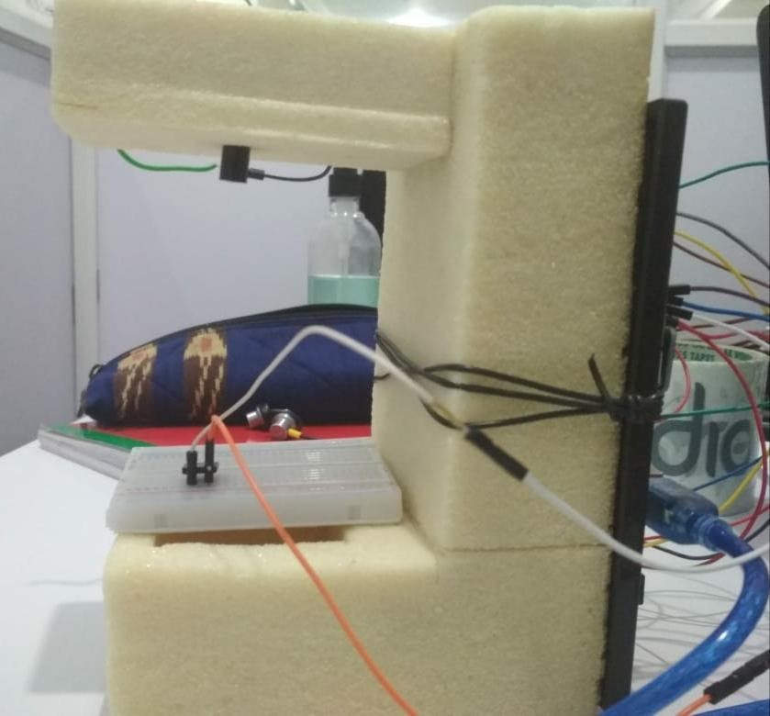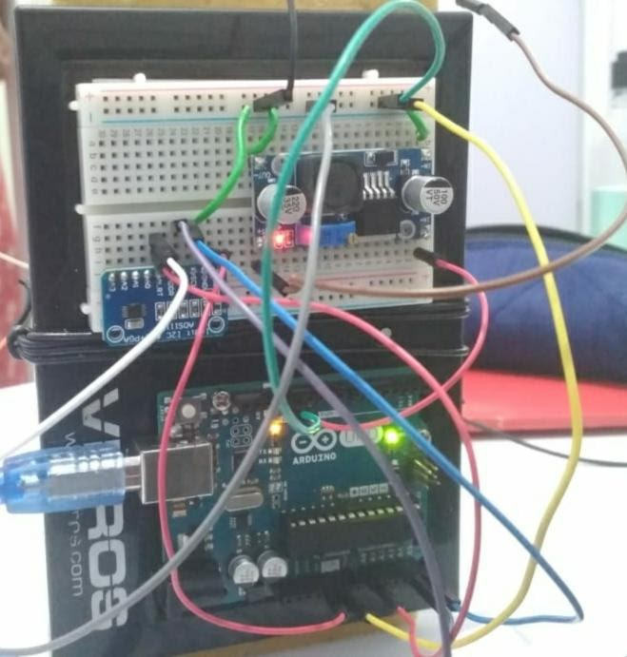

* + **Code:**

*#include <Wire.h>*

*#include <Adafruit_ADS1015.h>*

*#include <LiquidCrystal_I2C.h>*

*#define LED_BUILTIN 13*

*Adafruit_ADS1115 ads(0x48);*

*LiquidCrystal_I2C lcd(0x27, 20, 4);*

*// the setup function runs once when you press reset or power the board*

*void setup() {*

*Serial.begin(9600);*

*ads.begin();*

*lcd.init();*

*lcd.backlight();*

*lcd.setCursor(0, 0);*

*// initialize digital pin LED_BUILTIN as an output.*

*pinMode(LED_BUILTIN, OUTPUT);*

*LCDCode();*

*delay(1000);*

*digitalWrite(LED_BUILTIN, HIGH); // turn the LED on (HIGH is the voltage level)*

*for (int i = 0; i < 24; i++) {*

*LCDCode();*

*delay(10000);*

*}*

*}*

*// the loop function runs over and over again forever*

*void loop() {*

*digitalWrite(LED_BUILTIN, LOW); // turn the LED on (HIGH is the voltage level)*

*for (int i = 0; i < 24; i++) {*

*LCDCode();*

*delay(10000);*

*}// wait for a second*

*//. LCDCode();*

*digitalWrite(LED_BUILTIN, HIGH);*

*for(int i=0;i<12;i++){*

*LCDCode();*

*delay(10000);*

*}*

*}// wait for a second*

*void LCDCode() {*

*int16_t adc0;*

*adc0 = ads.readADC_SingleEnded(0);*

*int sensorValue = analogRead(A0);*

*double voltage_mV = sensorValue * (5.0 / 1023.0);*

*Serial.println(voltage_mV, 4);*

*// Serial.print("AIN0: ");*

*Serial.println(adc0);*

*//lcd.setCursor(0, 1);*

*//lcd.print("AIN0: ");*

*//lcd.print(adc0);*

*}*

* + **Calculations:**

Analog Values with MultiMeter

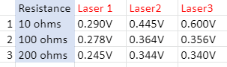

* + - **Look up table for detector selection for pigtail laser:**

|  |  |  |
| --- | --- | --- |
| **Detector** | **Blue** | **Red** |
| D1 | 0.0788 | 0.2747 |
| D2 | 0.0803 | 0.2678 |
| D3 | 0.0858 | 0.2705 |

**Note:** D1= Blue, D2=Red, D3=Green

**Part-4**

**Sensitivity Studies**

The Sensitivity of the Photo detector of S2386 & S2387 all the Records are plotted below:

* + **30 Minutes Readings**:

This is cycle of 4min on, 7min off, 1min on, 7min off and so on

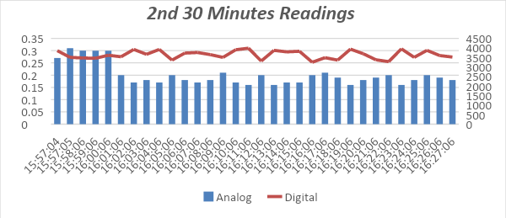

* + **30 Minutes Readings:**

This is cycle of 4min on, 7min off, 1min on, 7min off and so on

* + **1pF 30 Minutes Readings:**

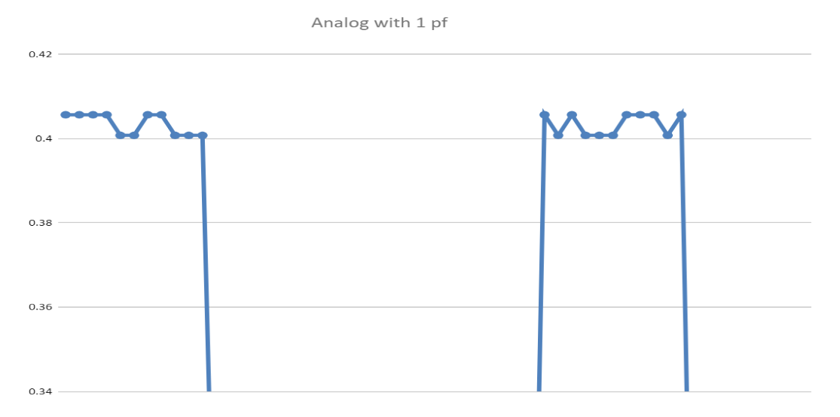

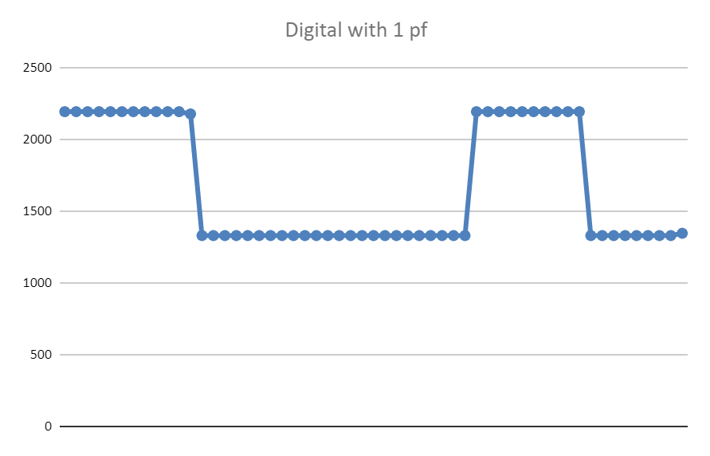

* + **10pF 15 Minutes Readings:**

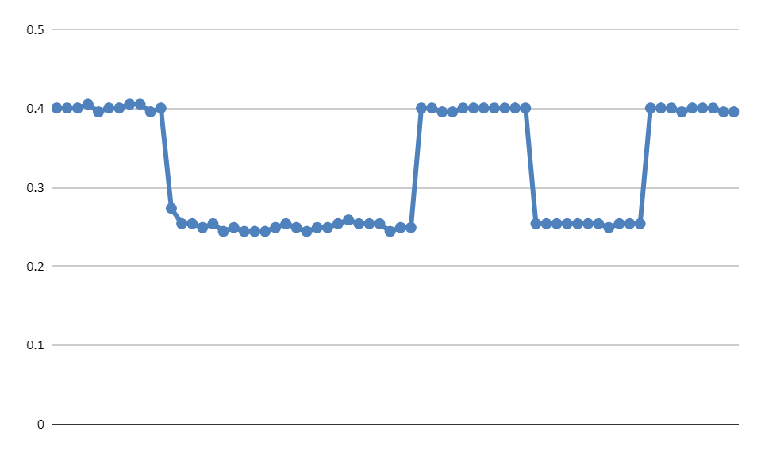

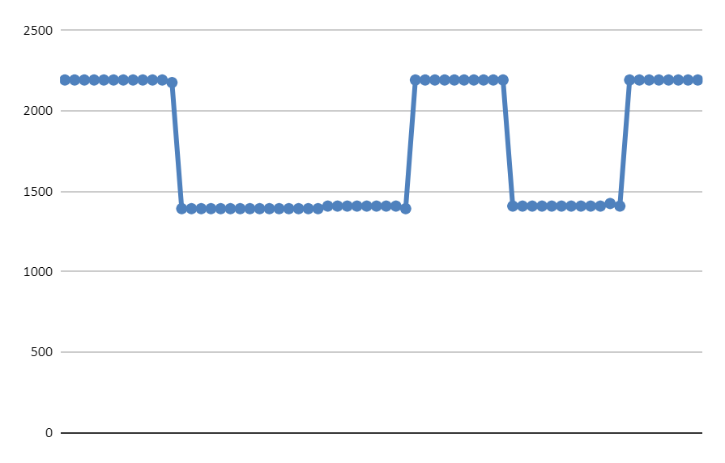

* + **101pF 15 Minutes Readings:**



